**What is a Smart Home?**

A smart home system can be something that makes our life relatively easy. Starting from energy management, where the power controls system in the AC appliances where we use the thermostat, all this is managed to cut down the power consumption that's taking place. A door management system, security management system, and water management system are part of this as well. Still, these vital things stand out in the smart home system. The limitation of IoT in smart home applications stops where our imagination stops. Anything that we wish to automate or want to make our life more accessible can be a part of a smart home or a smartphone system as well.

Figure - What is a Smart House?

It is essential to understand that a smart home now, usually is going to be a base of a smart city. The smart city is an evolution of a smart home. Here, it is not just the sensors of a single house that is connected; here it’s a correlation or a network or a connection between various organizations, various domains, as well as multiple segments of that city as a whole. In the smart city, the life of every dependent becomes more comfortable and in tune, which really helps to develop that city to a greater extent. Now, the critical factor for a smart city is government support, and if the governments are willing to take this step, then we hope we will see a smart city ultimately build on the Internet of Things. To have a complete understanding of how a smart home can simplify family life, watch this video:

Figure - Life Simplified with Connected Devices (<https://www.youtube.com/watch?v=NjYTzvAVozo>)

This infographic produced by Deloitte shows a good representation of this question.

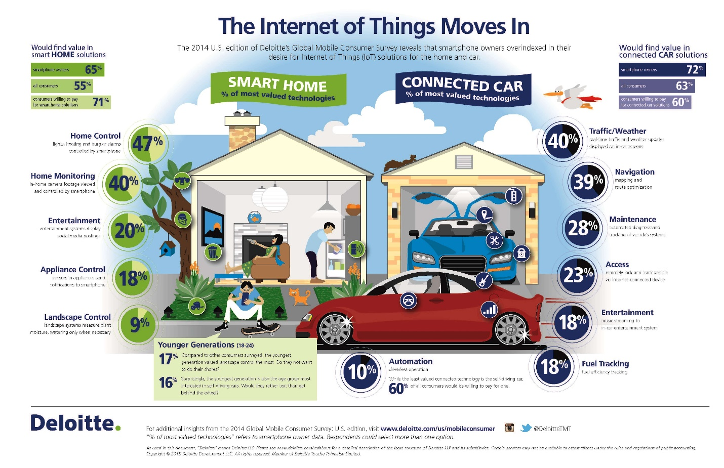

Figure - <https://www2.deloitte.com/us/en/pages/technology-media-and-telecommunications/articles/internet-of-things-global-mobile-consumer-survey-infographic.html>

**Smart Home Things**

These days, there's a smart version of every home device you can think of. These products connect to the internet so that you can control them from your phone via a companion app. Most also work with various forms of voice control.

Many smart home companion apps support scheduling, so you can easily program your devices to perform a specific action at a particular time. With Amazon Alexa and Google Assistant, you can set up routines to program your devices to work together and do multiple things simultaneously, like adjusting the temperature and lighting when you get home. With Apple HomeKit, you can control your devices with Siri voice commands or from an Apple Watch and create scenes to trigger several devices simultaneously. Using IFTTT[1], a service supported by many top intelligent home brands, you can link various internet-connected devices and easily program them to respond to real-world events, such as setting your lights to turn on automatically at sunset.

There are multiple types of things today; however, we explain to someone to have an idea about what you can do with them.

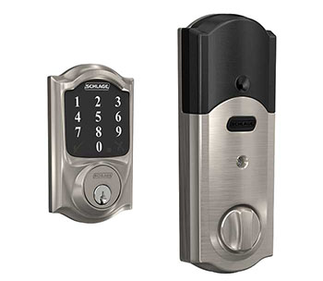

**Access**: Using smart locks and garage-door openers, users can assign and revoke timed virtual keys to anyone they like, from in-laws to dog sitters and visitors. Smart locks can also detect when residents are near and unlock their doors.

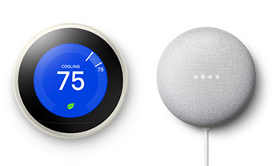**Climate Control:** Smart thermostats allow you to control your home heating and air conditioning systems by voice or app. A smart climate control system can also learn residents’ behavior patterns and automatically modify settings to adjust ambient temperatures for various rooms. The smart thermostats can also report energy usage and remind users to change filters, among other things.

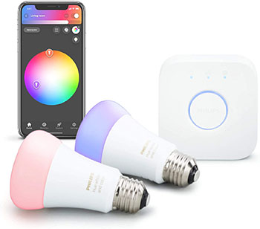**Lighting:** Smart lighting systems are available for indoor and outdoors use. Bright lighting adds automation, remote control, and other convenience features. Upgrading your lights to bright lights is one of the most accessible and most practical smart-home changes you can make in your residence. In addition to being able to be controlled remotely and customized, smart lighting systems detect when occupants are in the room and adjust lighting as needed. Smart lightbulbs can also regulate themselves based on daylight availability.

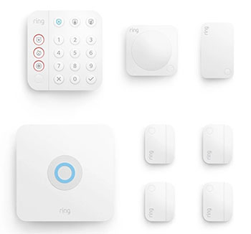

**Security Systems:** By using indoor and outdoor cameras, motion sensors, and smoke and carbon monoxide detectors, residents can automatically monitor their homes when they are away or, for instance at night when they sleep. **Smart motion sensors** can also identify the difference between residents, visitors, pets & burglars, ring alarms, and even notify authorities if suspicious behavior is detected.

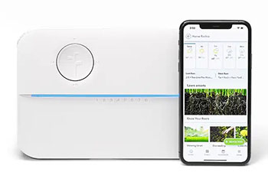

**System & Maintenance:** Monitoring systems can sense water failures or freezing pipes and turn off the water to prevent flooding or sense an electric surge and turn off appliances. As mentioned above, smart sprinkler systems can monitor weather conditions and soil humidity and optimize lawn irrigation systems accordingly.

**Smart Home Control Application**

The things will produce multiple data about their status and have support to receive remote commands. There are numerous possibilities; however, some ideas are:

One-click to…

* activate devices
* switch on/off light(s)
* configure automation, timetables

Check out…

* Temperatures in rooms
* Energy consumption
* Security cameras

**Smart Home Rules Examples**

However, a significant improvement to using an IoT architecture is not only to have access to status information from devices or to remote control but to use their data to produce smart systems that improve the quality of life. To understand the benefits of using Artificial Intelligence in the smart home, please read this blog material: ***“As artificial intelligence (AI) aids smart gadgets in making daily tasks easier; they are becoming safer.”***

An essential goal of IoT in home automation is energy efficiency. An example of a basic rule that can improve it is:

* 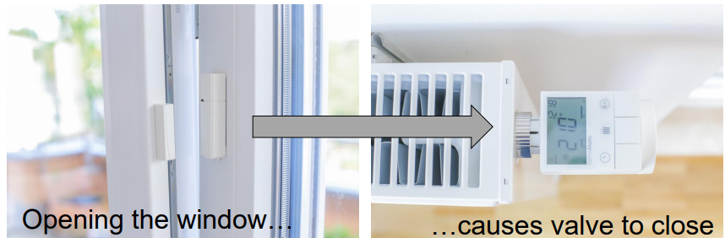**If** the Door/Window is opened, **then** the control valve of the heating radiator shall lower the temperature (for the duration while it is opened)
* Each degree Celsius can save 6 % of energy consumption per year.

Another example is the improvement of house security. An example of this feature is:

* **If** the Door/Window is opened during your absence, **then** turn on the alarm siren of the fire detector & send an email & send a push message on your smartphone.

**Exercise – Design a Smart Home**

**Goal:** The exercise aims to check the student's understanding of what is a smart home and, how IoT technologies can be used to automate the essential tasks of a house, and how they can increase the well-being, safety, and security of families. Also, it aims to check if students can design an IoT architecture based on three layers.

**Methodology:**

* Map all features and objects a typical house needs to have (ex., Gates, springles, lights, etc.).
* Find on the Internet IoT devices which can be used to automate a house.
* Read the datasheets of the found devices, aiming to identify their features (focus only on functional features, do not spend time analyzing protocols or other technical aspects).
* Using the course module material and the additional references (see in Canvas), design an IoT architecture to implement a smart home using 4-stages (see Figure 4).
  + Do not consider the Internet Gateway in your design.
  + Identify the features required for the Edge Layer.
  + Identify the features required for the Cloud Layer.
  + Select a Public Cloud Provider (Google, Amazon, Microsoft, etc.) and find which features can be used to build rules and provide analytics (transform data into smart information).

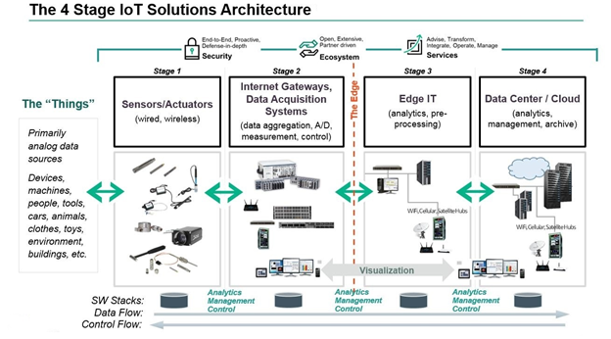

Figure - IoT Architecture 4-stages Architecture.

**Deliverable:**

Write a report (Spanish or English) with three pages (maximum four pages) with the following content:

* **Introduction:** define a smart home and how IoT can be used to improve families' well-being, safety, and security.
* **Development:** show the IoT architecture built and explain it.
* **Final Remarks:** write a conclusion, show the limitation of your document (topics that you do not research), and what is the next steps.
* **References:** using MLA style[2].

**Rubric**

|  |  |
| --- | --- |
| 100 – 85 pts  Full Marks | The report has a complete definition of the problem involved. Also, it defines a smart home and correlates it with IoT technologies. The report shows how IoT can improve families' well-being, safety, and security. The developed architecture contains the three required layers, and the student explains how it works. The solution uses real devices and systems to build the architecture, and they make sense. The conclusion is complete, cites what is not covered in the report, and shows future developments. The reference is written in the correct style, and the figures have good quality. |

|  |  |
| --- | --- |
| 84 - 70 pts  Advance Marks | The report has a complete definition of the problem involved. Also, it defines an intelligent home and correlates it with IoT technologies. The report shows how IoT can improve families' well-being, safety, and security. The developed architecture contains the three required layers, and the student explains how it works. The solution does not use real devices and systems to build the architecture, or they do not make sense. The conclusion is incomplete. The reference is written in the correct style, and the figures have good quality. |
| 69- 50 pts  Partial Marks | The report does not have a complete definition of the problem involved. However, it defines a smart home and correlates it with IoT technologies. The information does not show how IoT can improve families' well-being, safety, and security. The developed architecture contains the three required layers, and the student explains how it works. The solution does not use real devices and systems to build the architecture, or they do not make sense. The conclusion is incomplete. The reference is written in the correct style, and the figures have good quality. |
| 49- 20 pts  Insipient Marks | The report does not have a complete definition of the problem involved. Also, it does not define what a smart home is and correlates it with IoT technologies. The report does not show how IoT can improve families' well-being, safety, and security. The developed architecture contains the three required layers, but the student does not explain how it works. The solution does not use real devices and systems to build the architecture, or they do not make sense. The conclusion is incomplete. The reference is not written in the correct style, and there are lousy quality figures. |
| 0 pts  No Marks | The student did not submit the files required to deliver the activity. |

1. IFTTT derives its name from the programming conditional statement “if this, then that.” What the company provides is a software platform that connects apps, devices, and services from different developers in order to trigger one or more automation involving those apps, devices, and services.
2. https://scholar.google.com/